**Chapter 4**

**4.1: What is Light?**

**The Speed of Light**

* Ole Romer, Danish astronomer, discovered that light travels at a finite speed by look at Jupiter’s moons
  + He was a little under on his estimation of light speed though
* Speed of light = roughly 2.9979x108 (in a vacuum)
  + Light year = distance light can travel in 1 year
* Light carries energy
  + Usually the sum of all energies together result in an object’s temperature (the sun’s light heating things up)

**Light as a Wave**

* Unlike a water droplet, which requires a medium to travel through, light does not require a medium, but moves in the same fashion through space as a drop of water
* Light moves with 4 main attributes: amplitude (v), wavelength (lambda), frequency (f), and hertz (Hz)
  + Speed of wave: v = lambda * f

**Light as a Particle**

* As a particle, light is made up of massless particles called *photons* 
  + Photons always travel at the speed of light, c
  + Light is quantized, with a photon being a subdivision, or quantum, of light
* Energy of a photon and frequency of the electromagnetic wave are directly proportional to each other, with the proportionality constant *h* (Planck’s constant = 6.63x10-34 joule-sec)
  + Red light is low energy, blue is high energy

**E = *h*f**

**The Electromagnetic Spectrum**

* Electromagnetic spectrum is the range of different wavelengths of light
  + Light waves can be called electromagnetic waves

**R O Y G B I V**

* 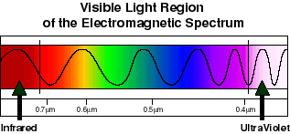Wavelength and frequency are inversely proportional, so short-wavelength light has high frequency (blue), and vice versa
* Astronomers use nanometers when referring to wavelengths

**Light and Matter**

* Protons, neutrons, electrons, ions
* When matter far from a source of light waves can absorb energy from that wave, a process called *absorption*.
* Matter also emits energy, called *emission.* 
  + Emission and absorption is essential to understanding the universe. We detect light by its interaction with matter

**4.2: Cameras and Spectrographs Record Astronomical Data**

**The Eye**

* Humans can see wavelengths between 350nm to 750nm.
* Integration time:
  + The time interval during which the eye can add up photons (think of leaving the shutter open on a camera lens)
  + Adds up every 100ms, so if 2 images appear within that time frame, they will appear as the same image
* Quantum efficiency:
  + Determines how many responses occur for each photon received.
  + The eye works at about 10% (10 photons strike a cone in your eye every 100ms to activate a response)
* Together, these two things determine the rate at which photons must arrive before the brain “sees” something
* Angular resolution also effects how we see stuff.
  + Refers to how close two points of light can be to each other before we can no longer distinguish them
  + Human eye can resolve objects separated by 1 arcminute (1/60th of a degree)

**Photographic Plates**

* 1840, John Draper created earliest known astronomical photograph
* By 1870, this form of observation became more popular
  + Quantum efficiency of these devices sucked, about 1-3 percent, but you can leave the shutter open, thus increasing the integration time, allowing you to observe a looooot more stuff

**Charge-Coupled Devices**

* 1969, Bell Laboratories developed CCDs.
  + The output from a CCD is a digital signal that can be sent from the telescope to image-processing software or stored for later use
  + A wafer of silicon is divided into an array of pixels. When a photon strikes a pixel, a small electric charge sends a digital signal to the computer that is proportional to this charge.
  + CCDs quantum efficiency is about 90%
  + CCDs are in digital cameras, video cameras, and other ish.

**Spectra and Spectrographs**

* By looking at Spectrographs through telescopes, information can be gathered about relative temperature, elemental composition, and other things
  + Elemental composition can be found by looking at emission/absorption lines which are unique to elements.
  + Temperature found by red light = low temp, blue = high temp

**4.3: Telescopes Collect Light**

**Refractors and Reflectors**

* Refracting telescopes
  + Uses a medium to “bend”, or refract, the light entering it
  + The *index of refraction,* or the amount of refraction, is found by taking the ratio of the speed of light in a vacuum *c* to its speed in the medium *v*

*N = c/v*

* + - Approx. 1.5 for glass
  + 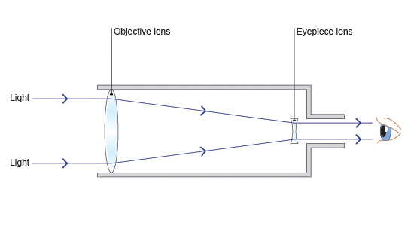In telescopes, as light enters the lens, it is refracted at varying amounts, creating a focal point where all of the light converges, creating an image on the *focal plane*
  + Drawbacks for these types of telescopes include the cost and *chromatic aberration*
    - *Chromatic aberration* produces blurry images due to different colors traveling at different speeds and thus refracting at different angles, and must be fixed using a filter (doesn’t 100% solve the problem though)
* *Reflecting telescope*
  + 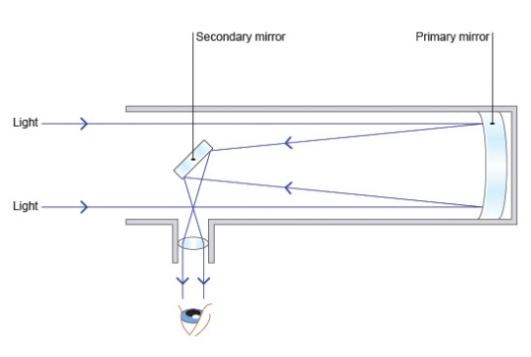Use a series of mirrors to focus light into an image, usually a primary and secondary mirror.
  + Chromatic aberration is not a problem here, they can weigh less, as well as many other advantages
    - All modern telescopes are usually reflecting

**Radio Telescopes**

* Radio telescopes, on their own, are far inferior to optical telescopes, mainly due to the poor angular resolution (lambda / D where lambda is the wavelength and D is the telescopes aperture (Diameter of the “dish”))
  + Radio waves are much larger than other waves, so a veeeery large dish is required to have a better angular resolution
  + This can be fixed by putting radio telescopes into arrays, significantly boosting the resolution by essentially by creating a very large aperture by taking the distance between the telescopes as D.
  + These array are called *interferometers* 
    - Very Large Array (VLA), Very Large Baseline Array (VLBA), and Space Very Long Baseline Interferometer (SVLBI) are examples

**Observing at Other Wavelengths**

* To see other wavelengths than radio, telescopes have to punch through the earth’s atmosphere, which is “cluttered” by infrared and ultraviolet waves. To get around this, observatories and telescopes need to be as high up as possible so that water vapor in the earths atmosphere doesn’t distort images
  + 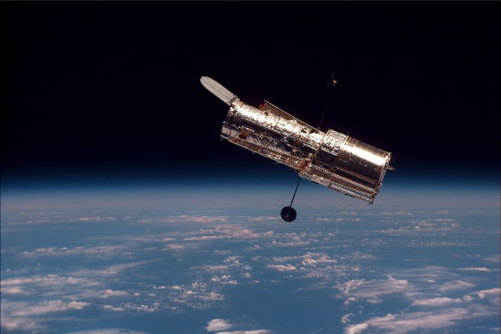Hubble Telescope, Spitzer Space Telescope, and others are examples that are extremely far from the surface of the earth

**Resolution and the Atmosphere**

* Diffraction
  + The distortion that occurs as light passes the edge of an opaque object
  + Slightly blurs images, the degree of blurring depending on the wavelength of the light and the telescope’s aperture
  + Best resolution a telescope can achieve is the diffraction limit
    - Larger the telescope, better the diffraction limit
  + Earth’s atmosphere stands in the way of better resolution most of the time, referred to as astronomical *seeing*.
* Modern tech has come up with *adaptive optics* which compensate for most of the atmosphere’s distortion.
* Nearly all X-ray, ultraviolet, and infrared light is absorbed in the atmosphere before reaching Earth’s surface